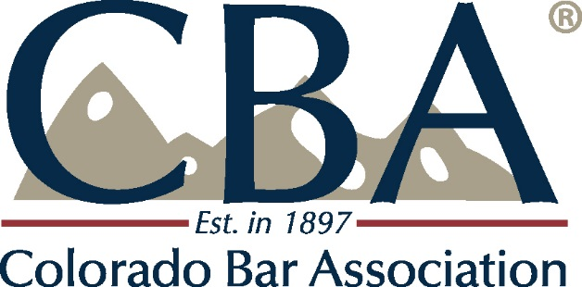

Minutes

BOARD OF GOVERNORS MEETING

Saturday, October 14, 2017 at 9 a.m. – 1:00 pm
Beaver Run Resort, 620 Village Road, Breckenridge, CO 80424

Please contact Melissa Nicoletti at melissan@cobar.org for the attendance list.

1. Call to Order, Welcome and Introduction of New Members – Meeting was called to order at 9:05. Dick Gast gave a short presentation on the history of CBA gatherings from dating back to his grandfather’s time as CBA president.
2. Approval of Minutes of the May 6, 2017 Meeting – Motion to approve minutes was made, seconded and approved.
3. CBA Financial – Key economic indicators – Mary Jo Gross reported that the CBA made money last year. Membership revenue is down from last year. The CBA is working on recruiting and retaining members. Year to date expenses are down and within the budget. The Audit Report for fiscal year 2017 was clean (and made available for review by the Governors).
4. CBA Update on Programs and Progress under the Strategic Plan – Patrick Flaherty reported on progress under the REFOCUS 20/20 strategic plan, and highlighted what has been done and what is to come.
What has been done?
- Web site Redesign
- Hired a recruitment/retention specialist
- Increased Social Media Presence
- Demographic survey
- Engaged diversity bars
- Staff local bar cohort
- Local bar working group
- Expanded mock trial program
- Brochure for those outside of the metro area
- Rebranded modest means task force
- Launched version 2 of the modest means took kit
- Received the Justice for All planning grant
- Doubled the number of unbundling road shows
- LSC funding lobbying
- Established satisfaction baseline
- Increased section & committee staff
- Section Best Practices Playbook
- Colorado Lawyer redesign
- Revised and clarified legislative guidelines
- COBALT leadership best practices
- YLD on nominating committee
- YLS in section councils
- Outreach to YLD to advise us on how to engage them
- Initiating new BOG orientation videos
- Improve the BOG meetings
- Department strategic plans
- Executive coaching for directors

Coming up:
- Customer Service Training
- Identify barriers
- Increase programming with diversity bars
- Bar offices relocation
- Local bar academy
- Local bar guide book
- Staff Training
- Section leadership orientation
- Tracking implementation
- Survey section satisfaction
- Committee best practices
- Expanding Law Practice Management through Affinity (will include 30 experts)
- Rebuilding find-a-lawyer database
- Re-orientation of Sections on legislation
- Continue to simplify entre points
5. Where is the BOG and where have we been? Courtney Holm reported that the CBA Executive Council Ad Hoc committee on the BOG continues to meet and continues to use the information from the Board of Governors meetings to create a description of each Governor’s role and expectations. Courtney also thanked the committee for all of their hard work. Under the new role the BOG members are ambassadors, leaders, bridge- builders, and innovators.
6. Leadership by Design: Embracing the Role of Ambassador – Mary Byers gave a presentation about the ambassador role of Governors and what it means to be a conduit of communication. We need to be thinking of the most efficient way to do business. We have a very large Board of Governors in comparison to other Bar Associations across the country. Being a bridge-builder in the association is a very important part of the role of the Board of Governors. Now how do we evolve and allow the Governors to bring information back to the Bar. BOG members are the eyes and ears of the Bar Association. They should be emailing and calling us to let us know what they are seeing and hearing out in the field. How can the Colorado Bar Association help members work less stressfully, more profitably and more productively? This may be a question that the BOG can help us answer. The Board of Governors knows more than most other CBA members. Trends coming in the legal profession are: Modest means, do-it-yourself lawyer, technological disruption, underemployment of new graduates, reduced law school classes, student debt, market decline, differing large firms vs. solo needs, new professional participation. What can the CBA do for members that they cannot do for themselves? Board of Governors members should share their stories with other members, on what the CBA has done for them. It is more important and powerful for people to hear why members personally are a part of the Bar vs. a list of reasons off of an elevator speech. . To share this message Governors need to figure out who to connect with, and who is the network to reach out to. People still want face to face communication, so look for those opportunities. Repetition is essential. How can members of the BOG communicate to their constituents that the constituents should come to them to find information on the CBA. The Governors also need to be the leaders in innovation for the CBA.
7. Breakout groups – The Governors met in breakout groups to discuss practical tools to help them implement their roles as ambassadors and conduits
8. Breakout groups provided the following feedback:
- Create an elevator speech
- Use existing networks to reach out to constituents
- Be the conduits of communications between sections and local bars
- One sheet of talking points to share with constituents
- Reach out to local leaders of groups who are underrepresented in the CBA and share with them experiences
- As representatives go back and share what you learned and share ideas, and share response to that back to the CBA
- Identify what medium law firms are underrepresented and send ambassadors out to those law firm administrators
- Find out who are non-members
- Disseminate and spread out the new member list to the local bar BOG members for reach out
- Use technology to get the message out, and ask EC to prepare the elevator speech
- Wear pins that indicate that we are CBA or CBA BOG members.
- Strengthen local, specialty bars and sections. Get information from them to get back to the CBA.
- Create a fund that members can contribute to so that they can sponsor lower income members.
- Discount for joining multiple bar associations.
- Give our constituents an update on the strategic plan
- Further mesh BOG and sections by allowing BOG members to attend the section summit.
- Talk about the way being involved in a professional organization can help lead to being more professional
Mary Byers concluded her remarks by posing various questions to the Governors. Why was the association created? It has always been to bring like-minded people together. People are involved so what they do makes life better for other people. Make your time in leadership meaningful by causing a ripple effect. So now…Who do you need to call?, What do you need to do?, Who do you need to see?, and What do you need to know?. “The basic task of leadership is to increase the standard of living and the quality of life for all stakeholders.”--Stephen Covey

9. Patrick Flaherty reported on inaccuracies contained in the letter sent to many of the CBA Board of Governors by Chris Forsyth. Only the letter regarding the CBA Board of Governors was addressed. No other materials were discussed.
10. Bylaws Changes - Dick Gast described the proposed changes to the CBA Bylaws. The first change was to clarify the term of the Diversity Bar Representative to the CBA in 6.2 (9). Second is the changing the name of the Diversity in the Legal Profession Committee to the Presidents’ Diversity Council and to include the description brought to us by the Council members. Other changes are sunsetting of the Paralegal Committee, and finally the sunsetting of the Environmental Sustainability Committee. Motion to approve the Bylaw changes was made, seconded and approved.
11. Justice for All Summit Recap – Kathleen Schoen reported that CBA and other stakeholders have been working to develop a statewide plan to help provide legal services to underserved populations. A survey of existing resources was conducted. 5 subcommittees met over the summer. This concluded with the Justice For All Summit held over r 2 days to look at recommendations and to comment on those recommendations. A strategic plan will now be prepared. First will be projects that can be done with current resources. Second will be programs easily attainable with little or no increase in resources. Last will be programs that need additional resources and further study
12. Federal Pro Se Clinic at the US District Court in Denver. Kathleen Schoen also reported that the CBA will be facilitating this program that will be funded solely by the US District Court. There has been research done on how other states have operated such clinics and we have used much of that information to structure this clinic.
13. Colorado Legal Services Report – Jon Asher publicly thanked Patrick, Dick and the CBA for traveling to Washington to lobby for Legal Services funding last spring.
12. Chief Justice Report – Chief Justice Rice reported that Chris Ryan has been appointed as the new state court administrator following a national search and interview process. The Chief noted that Justice Allison Eid may be leaving the Court if her appointment to the 10th Circuit Court of Appeals is confirmed by the US Senate. The Chief encouraged Governors to notify any constituents who may be interested in applying for the vacancy to have their information ready because once the vacancy occurs the nomination process proceeds quickly. There will be a proposal to increase the County Court jurisdictional limit to $35,000. There are also proposed changes to some CLE rules. One change will be to require CLE credit for those over 65. There will be a public hearing on the CLE rule changes and comments on rule changes are given careful consideration. In the judiciary budget for the coming year the focus will be on the staff.
13. CLE Update – Vince O’Brien reported that CLE is doing well. He thanked all of those in the room who speak at CLE and who give their time to write for the CLE publications. CLE is keeping an eye on the proposed CLE rule changes. If the live CLE rule change passes, CLE would like to partner with local bar associations to bring programming to various areas. CLE is considering a lower cost CLE pass for those over the age of 65.
13. President’s Report
- CBA Executive Council Report – The CBA Executive Council meeting minutes have been provided to the governors in their packet and are available on the web site. Highlights of the most recent meeting include acceptance of the CBA Audit and the abatement of rent for Legal Aid Foundation and COLTAF.
- Presidential Visits – Dick has been making his way around the state to visit with all of the local bar associations. The local bar associations have been very welcoming. Casemaker is a big draw for some rural attorneys. Also some of the more rural bar associations have great representation and leadership from the public sector.
- Looking at the year Ahead – Upcoming initiatives are the new Law Practice Management program, Local Bar Leaders Institute in June along with a Best Practices Manual to be used by local bar leaders.
14. The meeting was adjourned at approximately 11:55.

NOTE: The next meeting of the CBA Board of Governors will be Saturday, May 5, 2018 in Fort Collins, CO. Details will be sent soon.
Respectfully submitted,
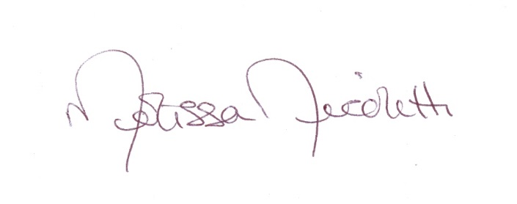
Melissa Nicoletti
Director of Sections and Committees

