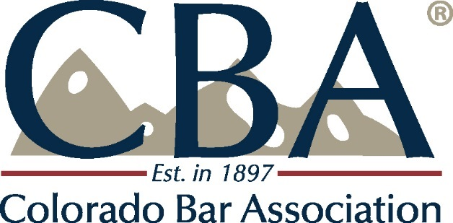

Minutes

EXECUTIVE COUNCIL MEETING

Tuesday, October 3, 2017, 3:00 - 5:00 PM
CBA Offices, 1900 Grant Street, 9th Floor, Denver, CO 80202

In attendance at the meeting were: President Dick Gast, Cobea Becker, Patrick Flaherty, Amy Goscha, Katherine Gregg, Mary Jo Gross, Steve Hahn, Franz Hardy, Patricia Jarzobski, April Jones, Casey Kannenberg, Bryon Large, Tyler Murray, Bonnie Schriner, Dan Sweetser, Mario Trimble and John Vaught. On the phone were: Courtney Holm and Judge Lance Timbreza. Staff in attendance were: Greg Martin, Melissa Nicoletti, Carolyn Gravit, Lori Krupske, Kath Schoen and Amy Sreenen.

- –The meeting was called to order by President Dick Gast at 3:05 PM.

- The minutes of the August 1, 2017 meeting were approved.

- Auditor Report - Dan Dibella of Fortner, Bayens, Levkulich & Garrison reported that the results of the Audit were positive for the Colorado Bar Association for the 2016-2017 year. The organization has good financial controls in place. Audit is conducted each year in July and the overall report can be found in the October Executive Council Packet. There were small changes made to the financial statements from last year. First was Net Assets; we now have to report unrestricted and restricted assets. The bulk of the CBA assets are unrestricted. Second was a breakout of direct costs and salaries. This breakout can be found of page 17 of the financial statements. All else for the year is very similar to our audit in previous years. Motion to accept the audit was made, seconded and unanimously approved.

- Treasurer’s Report was given by Mary Jo Gross.

- LAF/COLTAF Rent Abatement – Natalie Hanlon Leh and Diana Poole were present on behalf of the Legal Aid Foundation (LAF) and COLTAF. LAF’s sole mission is to give grants to Colorado Legal Services. Legal Services Corporation provides much of the funding for CLS, they also receive funds from private donors and other places. Federal funding is in jeopardy of being cut in this political environment. One of the great ways that the CBA and the DBA support LAF and COLTAF is to give them free rent for their administrative offices. Total we would save between the two organizations is approximately $20,000. This amount is split 35% / 65% with the Denver Bar Association. The CBA portion of this is $13,240. This amount is included in our Budget for the 2017-2018 year. There is a national effort to try to create a continuum of services that can help Legal Aid be a self-sustaining over time. There will always be a segment of people that will need free legal services. Part of this effort is the Justice for All grant that was given to Colorado and that the CBA is a part of working on. Motion to abate the rent for fiscal year 2017- 2018 made, seconded and unanimously approved

- CLE Update – Patrick Flaherty gave background of Colorado Bar CLE. It was noted that CLE is a separate entity from the CBA and the DBA, but both of these organizations are the members of Colorado CLE. It is defined by the IRS as a supporting organization of the CBA and the DBA. Therefore it exists exclusively for the benefit of the CBA/DBA, distributions to its members are allowed, CBA/DBA appoint the Board of CLE, he ED of the CBA and DBA is the managing director of CLE. Last year CLE posted record losses. CLE is now providing regular financial reporting to the CBA and the DBA. CLE has made significant changes, many of these changes have been positive for CLE. We now have a great working relationship among CLE, CBA and DBA. Financially CLE should finish 2017 with a slight surplus, and the draft 2018 budget includes distributions to the CBA and the DBA. CLE will be presenting their 2018 Budget to this group in December.

- Bylaw Changes – Clean up change on page 9 of the bylaws to clarify the length of the Diversity Bar Representative to the EC. Second change is the name change of the Diversity in the Legal Profession Committee to President’s Diversity Council and also the description of this committee. The description was approved by the President’s Diversity Council. Also the deletion of the Environmental Sustainability Committee and the Paralegal Committee. Motion to recommend approval of the Bylaw changes to the CBA BOG made, seconded and unanimously approved.

- Regional VP Reports –

  - 1st - No report.
  - 2nd Region – Dick is on his way to Brighton for his Presidential Visit. There are several CLE’s coming up in Adams county. There will also be a gift drive in December. All seems to be going along well.
  - 3rd Region – No report.
  - 4th Region – Working to establish the Southern Colorado Women’s Bar Association. They will be meeting to decide if they would like to partner with the Colorado Women’s Bar Association. Pueblo is always concerned that they do not have CLE programs in Southern Colorado.
  - 5th region – No report.
  - 6th Region – 6th just hosted both Dick Gast and Jeremy Schupbach for programs. There was also a YLD coffee event in Grand Junction.
  - 7th – It is snowing. 9th JD Bar is getting active, especially the young lawyers group. Northwest Colorado Bar in Steamboat will be having their winter social in December. Pitkin and Continental Divide is looking to ask the CBA to host their web site.

- Federal Pro Se Update – There are several federal pro se clinics around the country. Local Federal Judges approached Colorado Lawyers Committee about running a Federal Pro Se Clinic, they liked the idea but decided that the project was too large for them and asked the CBA to become involved. The CBA has been involved in ongoing conversations with the Federal Court. The Federal Court does have grant money available to be able to run the program. We now have a proposed contract and a Memorandum of Understanding. If approved here it will then go to the Article 3 judges for approval. This program can be done with no cost to the CBA, and is consistent with our strategic plan in that it enhances Access to Justice. CBA would be hiring an attorney to develop and run the program. It would most likely take us until March before the clinic could be open. Draft budget can be obtained from Kath Schoen kschoen@cobar.org. There was discussion about specifics of the program. A suggestion was made to revise the proposed contract by taking out the last sentence in paragraph 10 Page 3 , so that either party can terminate with 90 days notice. Motion to approve the contract with that change was made, seconded, and unanimously approved.

- Strategic Plan Report – Staff began doing these reports in 2016-2017. These reports will show the progress the staff has been making in their work with the CBA Strategic Plan. Included in the Council’s packet was progress up to now. Going forward the report will be simply reflect the current fiscal year. Past reports will be saved and posted on the CBA web site.

- Board of Governors Preview – BOG orientation videos are now up and posted on line. We hope to get some feedback from the videos. We will have a speaker, Mary Byers, at the October 14 meeting. Governors appreciate the phone calls made regarding the meeting by Council members. Council members would like to contact the folks who have already RSVP’d. It was suggested we change the way we circulate the list.

- Presidential Report – President Dick Gast reported that he has been touring the state for his Local Bar Association visits and has gotten good feedback from CBA Members.

- New Business - None

- The meeting was adjourned at 4:55 PM

Respectfully submitted,
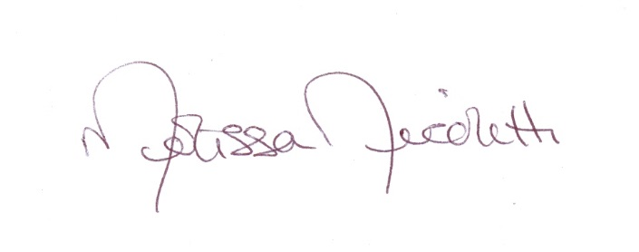
Melissa Nicoletti

Next Meeting Date: December 5, 2017

Links to Governing Documents

Link to by-laws: http://www.cobar.org/portals/cobar/repository/cbabylaws.pdf

Link to Articles of Incorporation: http://www.cobar.org/portals/cobar/repository/CBAArticlesOfIncorporation.pdf

Link to Strategic Plan Narrative: http://www.cobar.org/Portals/COBAR/Repository/Communications/CBA/Refocus%20Supporting%20Narrative.pdf?ver=2017-06-26-140048-557&timestamp=1498507258197

