Pressure Points In The
Colorado State Approved Form System

By: Jon Goodman

Frascona, Joiner, Goodman & Greenstein, P.C.
4750 Table Mesa Drive
Boulder, Colorado 80305
Facsimile: (303) 494-6309 Telephone: (303) 494-3000
http://www.frascona.com e-mail: jon@frascona.com

- Seller’s Property Disclosure (SPD19C-2-18) — Three types of questions:

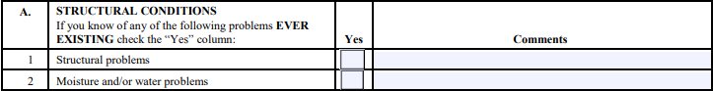

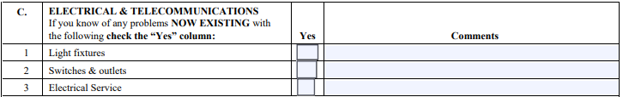

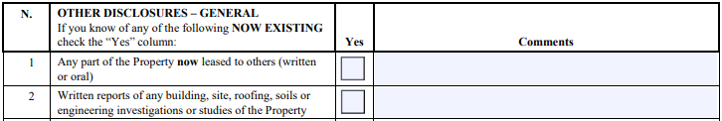

- Contract to Buy and Sell Real Estate

  - Incorrect legal descriptions.
  - Representation about buyer’s availability of funds (4.4.2):
Buyer represents that Buyer, as of the date of this Contract, ☐Does ☐ Does Not have funds that are immediately verifiable and available in an amount not less than the amount stated as Cash at Closing
  - Inspection 10.3 isn’t quite a free look contingency.
      - Zoning (10.6.3) (Not in basic residential contract.)
      - General land use (10.6.3) (Not in basic residential contract.)
      - Text not in the “CBS1 (Basic residential contract): 10.6.3 Zoning. Buyer has the Right to Terminate under §
25.1, on or before Due Diligence Documents Objection Deadline, based on any unsatisfactory zoning and any use restrictions imposed by any governmental agency with jurisdiction over the Property, in Buyer’s sole subjective discretion.

  - Lack of ability of Seller to kick buyer out of deal due to futility.

  - Lack of obligation to cooperate with other side’s need for a §1031 Exchange.

  - Lack of representations from the Seller:
      - Authority of the person signing.
      - No notice of bad things.

  - Lack of Prohibition against Seller shopping the contract.

  - Lack of pre-printed text to identify Seller-carry terms.

- Earnest Money Release: Is it a full release?
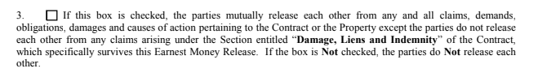
- Exclusive Right-to-Sell Listing Contract

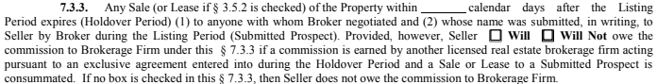

- Opportunity for Deep Education:

The nature of this fifty minute presentation is that it can only identify a small portion of the nuances of the Colorado Real Estate Commission Approved forms system. For a more thorough discussion see: COLORADO REAL ESTATE FORMS DESKBOOK, SECOND EDITION, CBA-CLE Books, 2016 (Updated May 2017; January 2019), Edited by James G. Benjamin, Esq.

