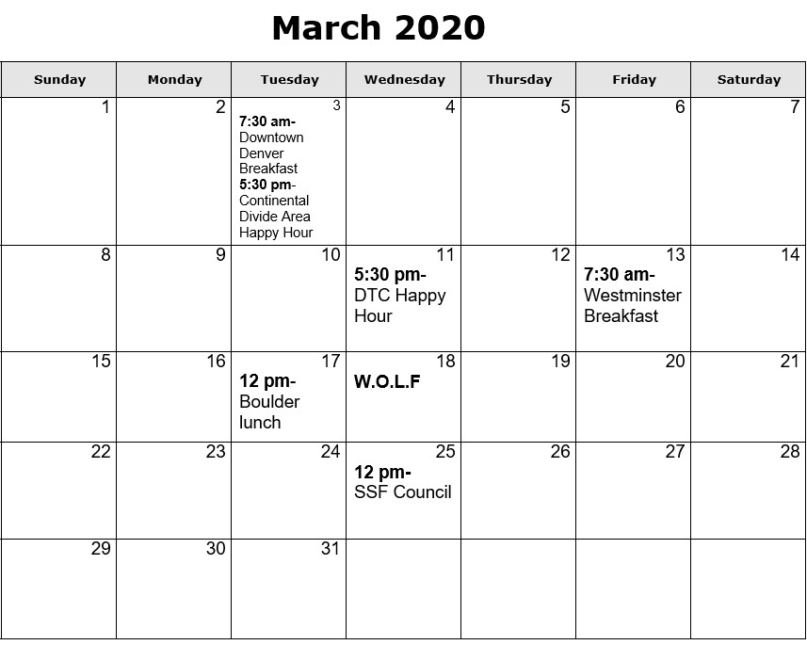

Boulder lunch- Third Tuesday of every month at noon, at Carelli's of Boulder, 645 30th St, Boulder, (303) 938-9300. Please contact Graham Fuller if you will be attending so he can provide a count to the restaurant, (303) 442-0802.

Cherry Creek/Glendale Brown Bag Lunch- May 15- 12:00 pm Ptarmigan Building, 3773 Cherry Creek Drive N, Suite 717, Denver, (303) 331-7967 Please RSVP to Amy Symons.

Continental Divide Area Happy Hour-
First Tuesday of every month at 5:30. Location to be decided - please contact Sandra Nettleton for details, (720) 232-0367

Downtown Denver Breakfast- First Tuesday of every month at 7:30. 1884 Restaurant (2nd Floor) inside the Denver Athletic Club, 1325 Glenarm Place, Denver, (303) 534-1211. Contact: D.A. Bertram, 303-871-9300

Downtown Denver Happy Hour- Second Tuesday of every month at 5:00 pm
Tupelo Honey, 1650 Wewatta St, Denver, (720) 274-0650. Please contact Jessica Hoyt, (970) 985-9444.

DTC Happy Hour- Second Wednesday of every month at 5:30 pm, Bar Louie, 8000 E. Belleview Ave, Greenwood Village, (720) 213-7080. If you plan on attending, contact Dave Sprecace, (303) 454-8260

Westminster Breakfast- Second Friday of every month at 7:30 am The Delectable Egg, 1005 W. 120th Ave, Westminster, (303) 451-7227. Group Name: SSFs Still Figuring It Out, General discussion on running a cost effective practice and the growing pains of a new(er) business. Contact Rachel Sheikh, (720) 515-2219

Colorado W.O.L.F. (Women Owned Law Firms) will be holding its March Quarterly Membership Meeting on Wednesday, March 18, 2020 at Blanchard Family Wines in Denver. March's Quarterly Meeting will feature a live demonstration of Discovery Genie, proud sponsor of Colorado W.O.L.F. and host of the wine tasting following the meeting. Interested in learning more about Colorado W.O.L.F. or March's event? Please email Barb Heikoff. Registration for March's event will close on March 15, 2020.

